COS30017 Assignment 3
  - Mark Saleh 103994313
Assignment 3 for COS30017 is an exercise tracking application that allows users to track their exercises over time, and to add, delete, view and edit information on their exercises. It consists of three activities: a main activity in which the user can view the list of their exercises and delete one if they wish, an activity for exercises, and an activity for viewing and editing data on each exercise. These exercises are stored in an internal file so that changes are saved even when the app is closed and relaunched, and managed through advanced components such as ViewModels and LiveData.

UI/UX
The original plan for this application was quite different from the final result. It included a calendar at the bottom of the screen, and a number input so that users can input the number of reps of each exercise they did daily, and view their progress by clicking the app. However, it was decided to make the application more flexible by having the exercise data be a simple String in which the user can choose to record their daily number of reps, weight or any other form of progression. Unfortunately, screenshots were not taken of the earlier form of the app, although it is provided in its Github history.
Below are screenshots of the final result, showing all three activities:
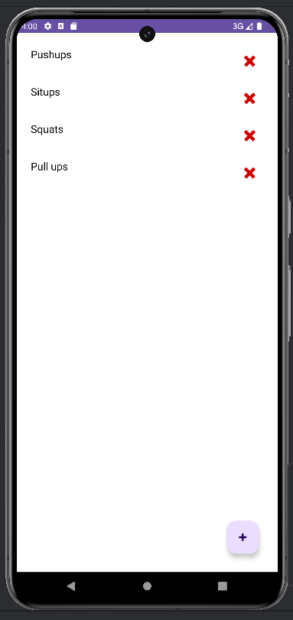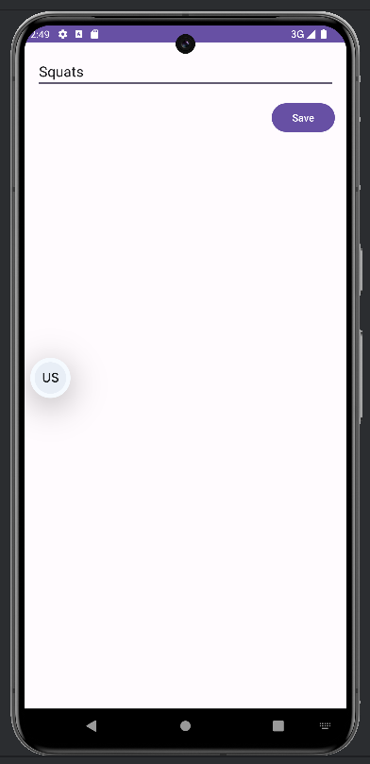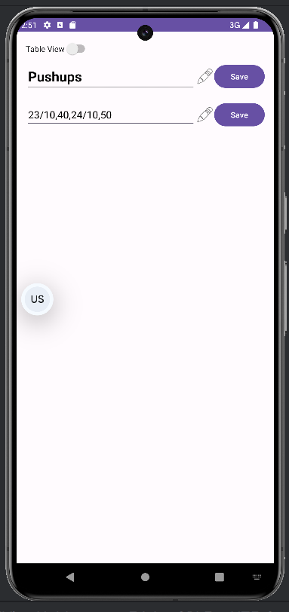
Figures 1-3: MainActivity (left), AddExerciseActivity (centre) and ExerciseDetailsActivity (right)
The ExerciseDetailsActivity has an additional Table View mode, in which the user can view their data as a two-column table. This is useful in logging progress, as one column could be for dates and the other could be for numbers of reps, sets or weights.
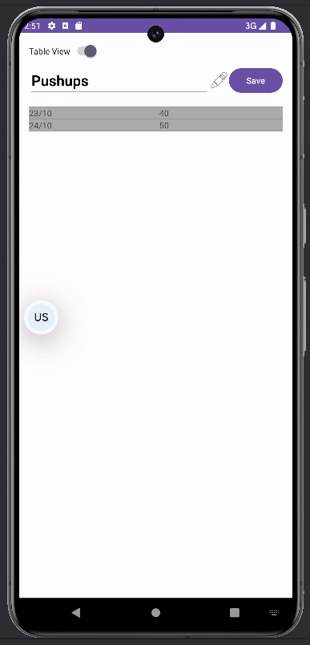
Figure 4: ExerciseDetailsActivity in Table View mode
Eight layout files were used: activity_main.xml, item_exercise.xml, activity_add_exercise.xml and activity_exercise_details.xml, as well as landscape versions of each of those. item_exercise.xml does not show a screen of its own, but is instead part of a RecyclerView on the main menu. ViewModels and Intents ensure that all data remains when the screen is rotated. Below are screenshots of all three possible screens in landscape mode:
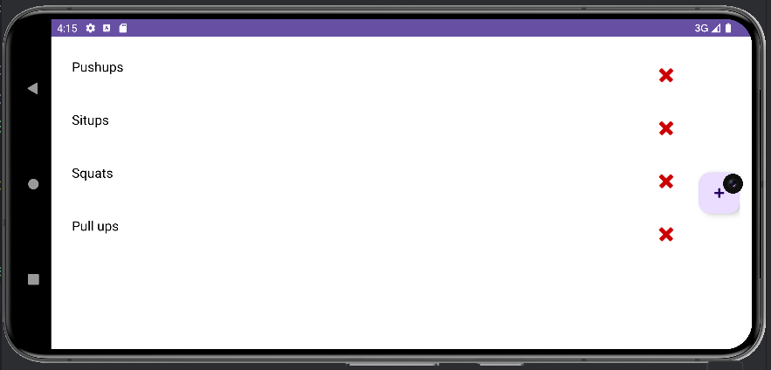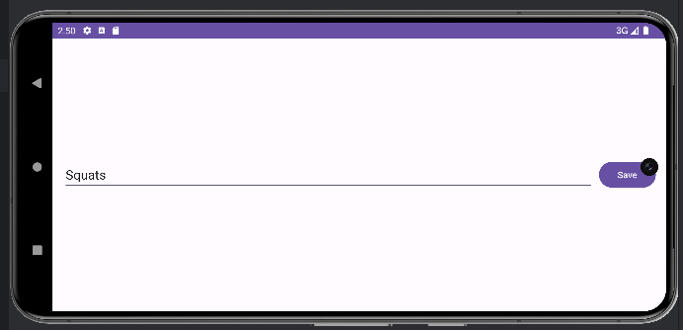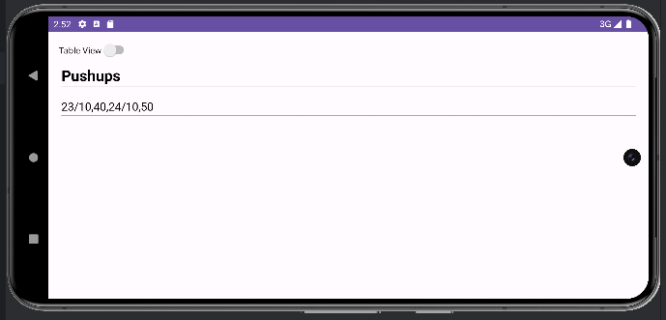
Figures 5-7: MainActivity (above), AddExerciseActivity (centre) and ExerciseDetailsActivity (below) in Landscape Mode
To further improve the app's usability, the text was not hardcoded, and both an English and a Japanese strings file were added to translate the text. This app does not have much text of its own, since most of the text it displays is ultimately from user input, but this screenshot shows the Japanese version of the app:
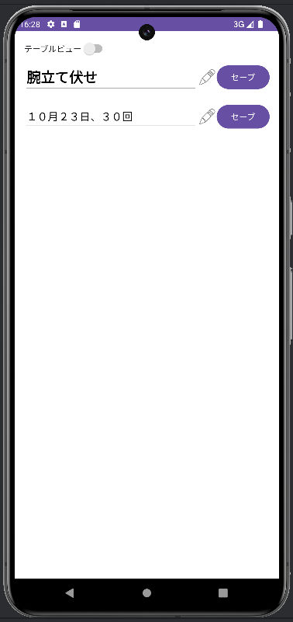
Figure 8: The app in Japanese. Note that the word "腕立て伏せ" (pushups) and the Japanese date format were manually inputted by the user
Furthermore, both light and dark themes were implemented. These screenshots show the three possible screens of this application in dark mode:
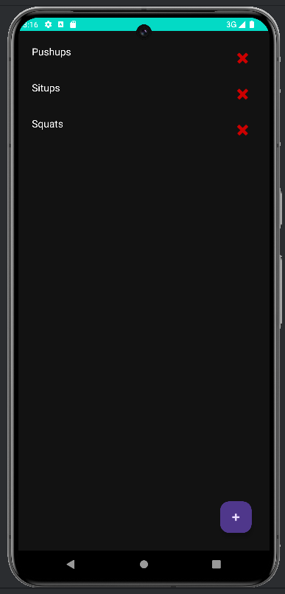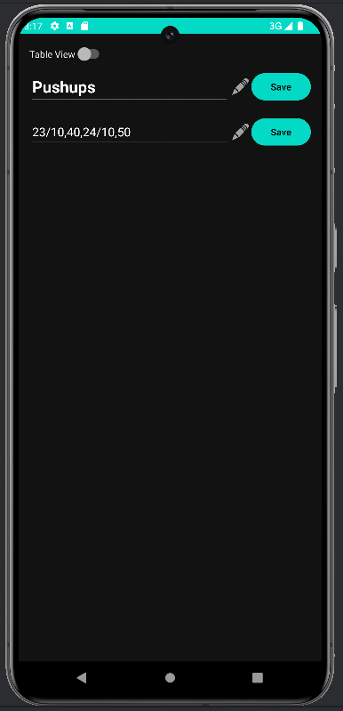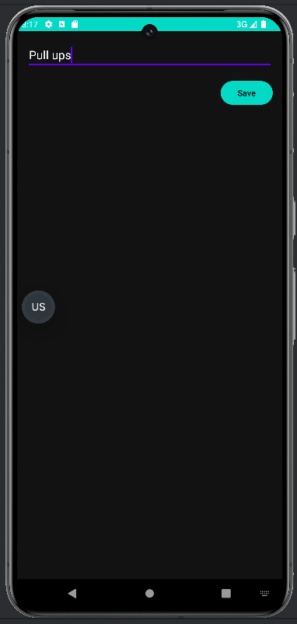
Figures 9-11: MainActivity (left), AddExerciseActivity (centre) and ExerciseDetailsActivity (right) in dark mode
To improve the user experience (and help with debugging), Toasts were added to inform users when an exercise has been edited or deleted, or if an error occurs during one of those processes. Below are screenshots of these Toasts:
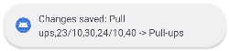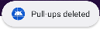
Figures 12-13: Screenshots of the Toast messages
These design choices were guided by research into User Experience Design. For example, Google's open-source design system, Material3, uses cyan by default in dark mode.^{[1]} The Toasts fulfill one of Nielsen's usability heuristics, which recommend giving the user feedback after a successful action.^{[2]}

Use Cases
The following use cases illustrate how this application may be used. User 1 is a fitness enthusiast who wants to track his workouts so that he can view his progress in each exercise over time. User 2 is training to run a marathon, and regularly times herself running and logs the time. After noticing a mistake, she wants to edit her previous times to make sure they are accurate.

Use Case 1
After doing leg day, User 1 opens the app and finds the exercises he did: leg extensions, squats and deadlifts. He clicks each exercise and clicks the edit button. He adds the current date, followed by a comma and the amount of weight and number of times he performed it. When he clicks the save button, the app gives him a toast to assure him that his edits were saved. He smiles when he sees his earlier logs and realises how far he has come.

Use Case 2
User 2 opens the app and clicks on the only exercise she has. After the details screen loads, she turns off Table View and clicks the edit button. Going through each entry in her log, she adds a minute to account for the slightly shorter route she had practiced. When she is done, she clicks "save" and her updates are saves.

Functionality
This app is, at its core, a CRUD application. The exercises are saved in an internal file titled exercise.txt. When the app starts, it reads from this file and loads the exercises. Once the app starts, a RecyclerView is created. An adapter creates an Exercise item from each line in exercise.txt and adds it to the RecyclerView. ViewModels are used to display the Exercises, which saves resources and ensures that the data remains even if the screen is rotated. There is a floating button on the MainActivity screen that leads the user to the AddExerciseActivity, and each Exercise has two OnClickListeners: one to delete the exercise and one to lead the user to the ExerciseDetailsActivity.
The AddExerciseActivity is quite basic. It has an EditText which lets the user input the name of the exercise, and a save button to save it. Due to the way exercises and their data are saved in exercise.txt, it is possible to add data to the exercise from the AddExerciseActivity by just putting a comma after its name, but this is not the intended way to do so.
The ExerciseDetailsActivity on the other hand is much larger, consisting of 108 lines of code (while AddExerciseActivity has just 29). It allows the user to separately edit both the name and data of the Exercise they clicked. It also allows them to view the exercise's data as a two-column table, which can be switched on or off using the Table View switch in the top of the screen. The two-column table is convenient for logging dates and exercises.
Testing was performed both manually and using Espresso, which resulted in many bugs being discovered. For example, deleting an exercise will temporarily make the exercise after it disappear from view too, although it returns when the MainActivity screen is refreshed. Another example is that the app keeps adding commas to the exercise data for some reason. It is such a bizarre, inexplicable glitch. Four tests with self-explanatory names were conducted in Espresso: an addExerciseTest to ensure that exercises are properly added, a deleteExerciseTest to make sure they are likewise deleted, a viewExerciseDetailsTest to ensure that the ExerciseDetailsActivity opens, and a toggleTableViewTest. Below are the results of these tests:
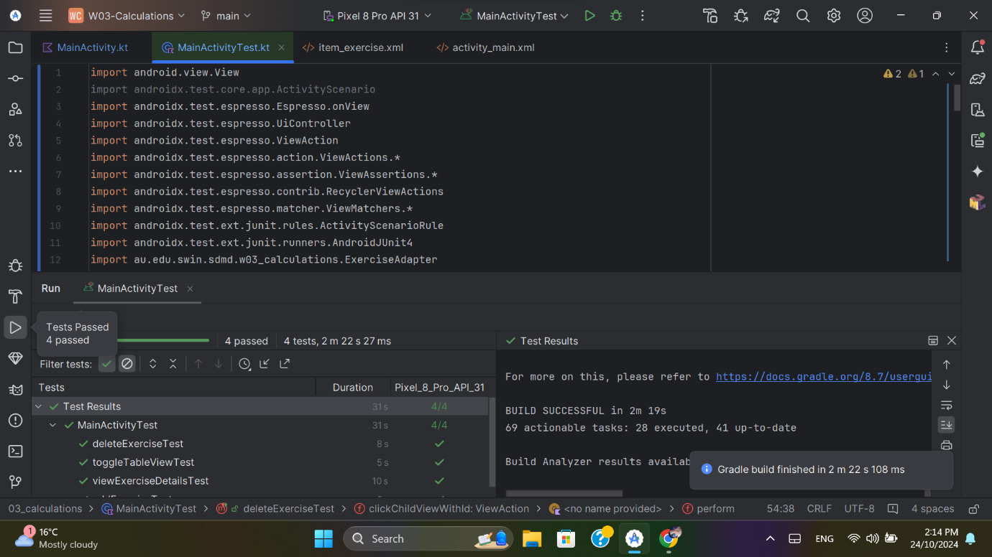
Figure 14: A screenshot of all 4 Espresso tests passing

Code Quality
During the coding of this app, care was taken to abide by best practices and Android style guides. To make the code modular and easier to maintain, its functions were separated into three Activities and several helper classes. An adapter and ViewModels are used to reduce coupling and efficiently handle data. And the data is stored in an internal file, which allows the app to work offline and retain data between sessions.
Readability and naming also follows the established and Android-recommended conventions. For example, camelCase is consistently used for variables. Methods all have self-descriptive named (like addExercise, deleteExercise and toggleTableView) which makes the code easy to follow. Comments are used to explain important or complex sections.
Following the assignment's instructions, advanced components such as ViewModels and LiveData were used. The LiveData allows the list of exercises to be updated without manually refreshing it. Besides those, the code is as optimised as possible. AddExerciseActivity, for example, only contains the necessary code to add new exercises, with most of the formatting being dealt with by the ViewModels.
Another way in which good coding practices were followed was the avoidance of hardcoding text and colour values, with allows for localisation and multiple colour scheme. This was exploited by creating a Japanese version of the app and a dark mode version.

Process and Demo
The process through which the code was developed can be followed through its Github commit history. In case this hyperlink does not work, here is the URL of its Github repository:
https://github.com/SoftDevMobDev-2024-Classrooms/assignment03-1MasterSpark
The code was demonstrated to Ms Grace Tao on the 24th of October. Based on her recommendations, more advanced components (such as ViewModels and LiveData) were incorporated, and a dark mode, Japanese localisation and landscape mode were all implemented. The process was unusually difficult for this assignment largely due to issues with libraries. Both Room and Firebase did not work, forcing me to resort to using an internal file, and the code only reached its current state after three and a half days of constant work on it. This can be seen in its Github history.

References
- Material Design. (n.d.). Material Design. https://m2.material.io/design/color/dark-theme.html
- Nielsen, J. (2024, January 30). 10 Heuristics for User Interface Design. Nielsen Norman Group. https://www.nngroup.com/articles/ten-usability-heuristics/
Generative AI tools were used as a coding and debugging aid.

